Release document-M10
Document ID: ASP-DRSYS-RD-10
Author(s): Rajesh K
Table of Contents

1. Sections Delivered 2
2. Perforce Check-in 2
3. Execution Machine 3
Milestone10 Executable 3
4. Jenkins Execution 4
5. Deliverables 4
6. Mobile Automation Setup 5
Mobile Settings 5
7. Appendixes 5
Executables Location 5
Milestone1 Executable 6
Milestone2 Executable 6
Milestone3 Executable 6
Milestone4 Executable 6
Milestone5 Executable 7
Milestone6 Executable 7
Milestone8 Executable 7
Cucumber execution Report 7
User Defined Report 8
HL7 Utility 9
Issues 11
Changes 14
Test Case Exceptions 14
Milestone1 14
Milestone2 14
Milestone3 16
Milestone5 20
Milestone6 23
Milestone8 27

Sections Delivered
This delivery contains Milestone 10 deliverables.
Milestone 10 contains deliverables related to Mobile items as mentioned in the Test Automation Plan.
The following sections constitute Mobile,
- Allergies
- Family History
- Medications
- Problems
- Smoking Status
- Vitals
- General

The “Automation Traceability document” includes the overall details of the deliverables.

Perforce Check-in
The scripts developed in Aspire are shared across to DRSYS using Perforce shared by DRSYS. The scripts of Milestone 10 is checked in under the location //SQA/eHR_SQA/eHR
The folder structure of eHR has been changed for adding Mobile Automation into the framework.
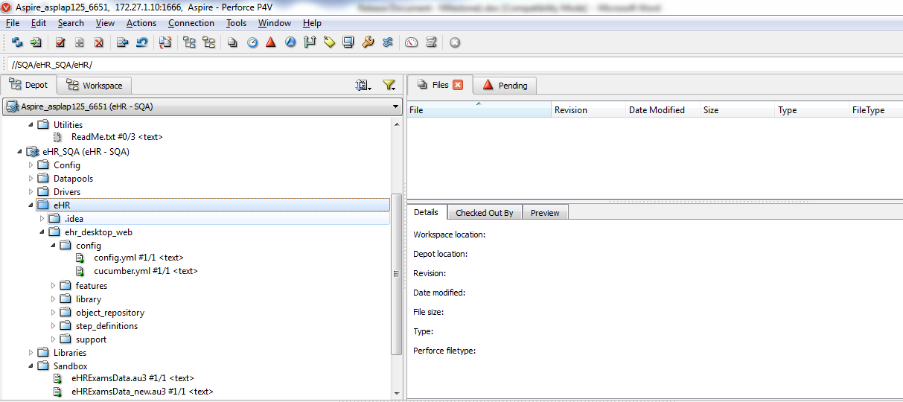

Execution Machine
As provided by DRSYS, the automation execution machine “172.27.101.114” will be used for testing the scripts by DRSYS QA. The mobile automation setup should be performed before execution of the scripts.[The setup process are mentioned in the document “Mobile_Automation_for_Android”] For now, the scripts are placed under the location “D:\Automation\eHR “.
Machine Details:
Machine IP: 172.27.101.114
Machine Name: VM-eHR-Automation
Chrome Version: 39.0.2171.95 m
The batch files are available in desktop under the folder “Automation Test Executables”.

Milestone10 Executable

Chrome_M10.bat: Starts execution in Android (device) mobile Chrome browser for complete milestone10 deliverable.

Jenkins Execution
Jenkins is setup at DRSYS and execution using it has been confirmed. Jobs for all milestone execution are setup for automation execution. Parallel execution using Jenkins is setup at both DRSYS and Aspire Systems and successful execution using it has been confirmed.
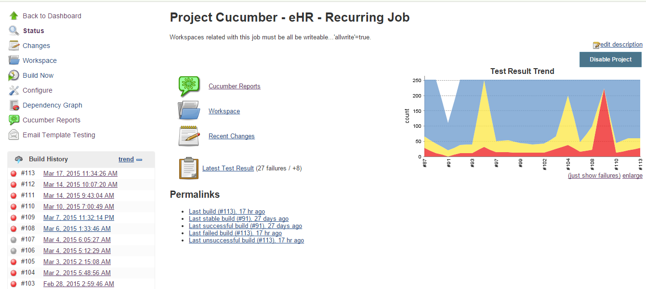

Deliverables
Following are the deliverables which are shared with this release,
- Scripts [shared through Perforce as mentioned in section 2]
- Automation Traceability document
- Verification Points document – Milestone10
- Android (device) mobile Chrome Execution report – “Android Chrome M10 Execution Report.html “, attached in the email
- Mobile_Automation_for_Android document – Setup document for Android mobile automation

Mobile Automation Setup

Mobile Settings
Android execution setup:
All the necessary environment settings for Android mobile automation are given in Mobile_Automation_for_Android.docx file.

Appendixes
Application details:
- Ruby – 2.0.0
- Chrome Driver - v2.11.298604
- Ruby Mine – 6.0.3
- Android SDK 19
- Appium - 1.3.4.1

Executables Location
The batch files are available in desktop under the folder “Automation Test Executables”.

Milestone1 Executable
Chrome_Issue_Fix_M1.bat: Starts execution in Chrome browser for the issues reported by DRSYS QA [TC id – 676 and 678]
Internet_explorer_M1.bat: Starts execution in IE browser for complete milestone1 deliverable.
Chrome_M1.bat: Starts execution in Chrome browser for complete milestone1 deliverable.

Milestone2 Executable
Internet_explorer_M2.bat: Starts execution in IE browser for complete milestone2 deliverable.
Chrome_M2.bat: Starts execution in Chrome browser for complete milestone2 deliverable.

Milestone3 Executable
Internet_explorer_M3.bat: Starts execution in IE browser for complete milestone3 deliverable.
Chrome_M3.bat: Starts execution in Chrome browser for complete milestone3 deliverable.

Milestone4 Executable
Internet_explorer_M4.bat: Starts execution in IE browser for complete milestone4 deliverable.
Chrome_M4.bat: Starts execution in Chrome browser for complete milestone4 deliverable.

Milestone5 Executable
Internet_explorer_M5.bat: Starts execution in IE browser for complete milestone5 deliverable.
Chrome_M5.bat: Starts execution in Chrome browser for complete milestone5 deliverable.

Milestone6 Executable
Internet_explorer_M6.bat: Starts execution in IE browser for complete milestone6 deliverable.
Chrome_M6.bat: Starts execution in Chrome browser for complete milestone6 deliverable.

Milestone8 Executable
Internet_explorer_M8.bat: Starts execution in IE browser for complete milestone8 deliverable.
Chrome_M8.bat: Starts execution in Chrome browser for complete milestone8 deliverable.

Cucumber execution Report
The execution report consist of the following,
- HTML report : This is auto generated by Cucumber driver and has details of the complete execution
- Log Files : This can be used for report analysis purpose
- Screenshots: The screenshots for any failure is captured and the same is embedded to the HTML report. The file location of the screenshot is also mentioned in the log files generated.

User Defined Report
The User defined report will be generated under “custom_report” folder, it holds the HTML report files created based on cucumber generated report. Cucumber generated html report has all-in-one page report summary which is not convenient for analysis purpose. Hence, a custom html report was created by splitting the cucumber-report into multiple html files. The consolidated execution summary will be in “report_home.html” file and will have the links to all other feature files holding grouped scenarios report data. This report includes all execution details along with the screenshot for failed cases. The HL7 messages generated during automation run will also be available under Screenshot folder.

Report_home.html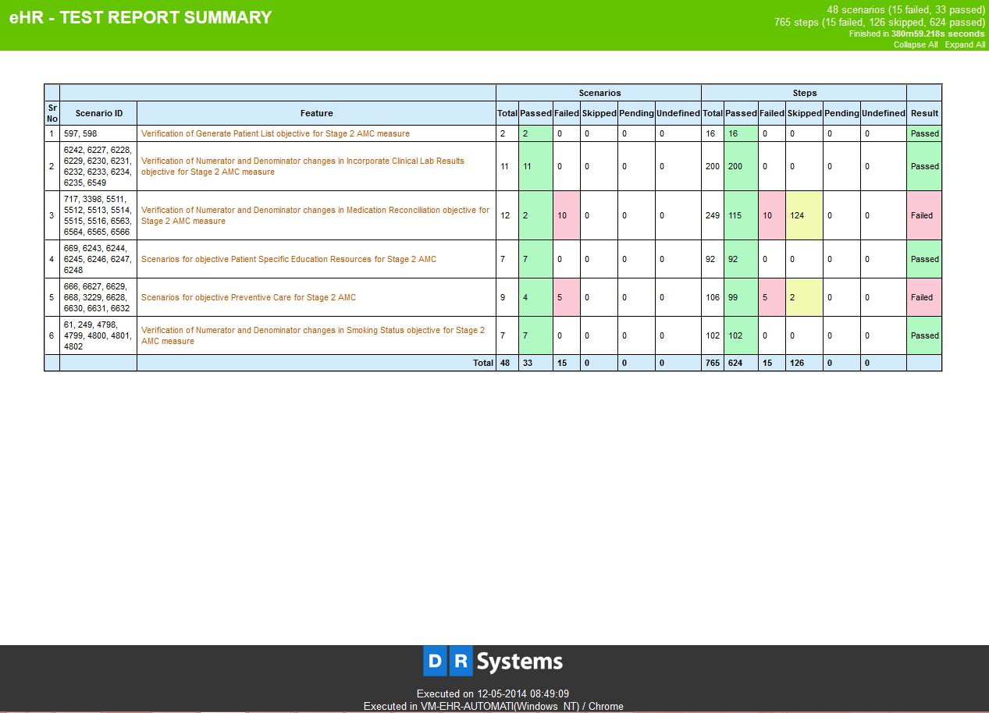

HL7 Utility
The HL7 messaging has been implemented in TAF using a JAR file (HL7Sender.jar), which is present in location “eHR\ehr_desktop_web\library\app_utils” directory. Various HL7 messages are placed in different template files and are available in “eHR\ehr_desktop_web\library\hl7_messages\templates” directory.
HL7 Sender.jar
The command for sending HL7 messages using HL7Sender.jar is
Java –jar <Filepath>\HL7Sender.jar --host=<Host Name> --port=<Port No> --file=<Complete file path>
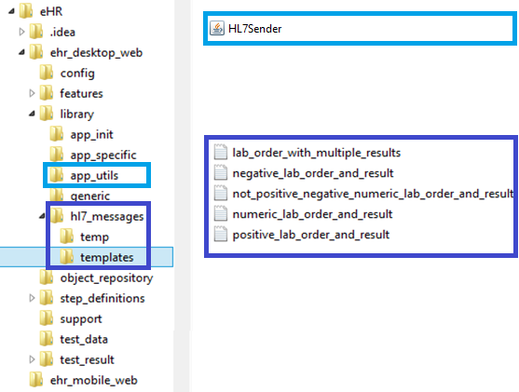

Find below the details of the parameters to use with HL7Sender.jar,
- Host ( --host ) : This parameter takes in the IP address or the system name of the server which hosts HL7 server.
Eg : Java –jar <Filepath>\HL7Sender.jar --host=172.27.101.81 --port=<Port No> --file=<Complete file path>

- Port ( --port ) : This parameter takes in the port number to which the message has to be sent.
Eg : Java –jar <Filepath>\HL7Sender.jar --host=172.27.101.81 --port=12826 --file=<Complete file path>

- File ( --file ) : This parameter takes in the complete path of HL7 message file.
Eg : Java –jar <Filepath>\HL7Sender.jar --host=172.27.101.81 --port=12826 --file=” D:\eHR\ehr_desktop_web\library\hl7_messages\temp\ numeric_lab_order_and_result.txt”

Issues
- In Vital Signs Objective, Numerator record not getting added as per Numerator count increment, only one page displayed in ‘Vital Signs - Numerator Recordings’ page.
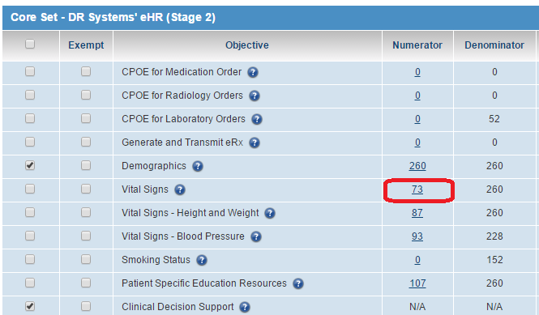
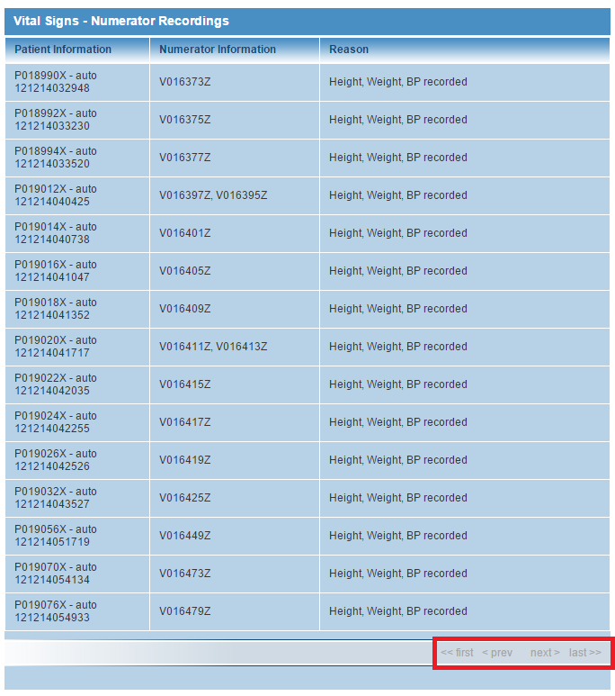
- In Incorporate Clinical Lab Results Objective, Numerator Recording page consist some additional pages with ‘No records found’ text.
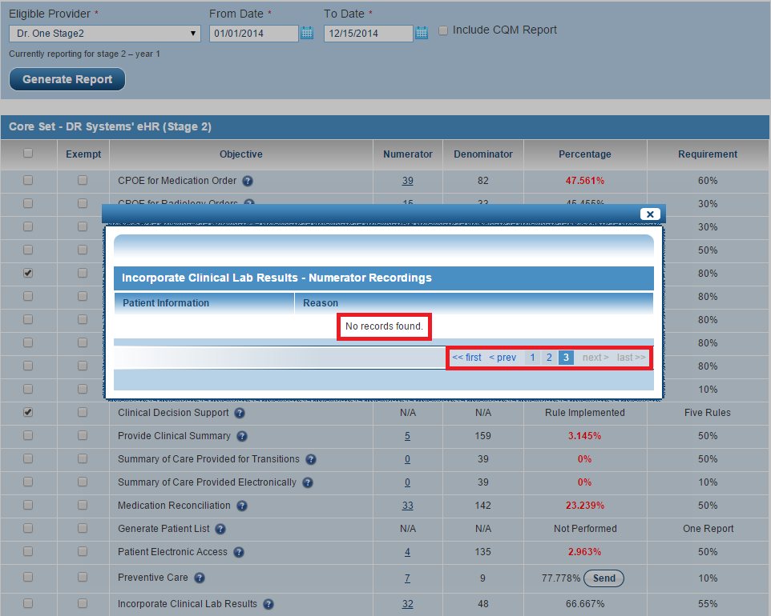

Changes
The following changes have been made in the Test Automation Framework,
- Dynamic input config handling: Parallel execution using all combinations of IE and chrome browsers in the same machine has been done. A new key ‘in_use’ has been added in config.yml file to identify if that set of config details is in use.
- The Jenkins plugin which have been used will search for JSON file in the folder and it will grab all the JSON files under that folder [including sub-folders]. So, the past results are also getting included in this case. A fix has been provided in script; such that only one JSON file [currently executed report] will be available in .json extension and older files extension renamed by .json1, so the Jenkins plugin copy the current JSON file.

Test Case Exceptions

Milestone1
- eRX mailbox should be up and running without any issue in 172.24.101.113
- The medication “Acyclovir (Buccal) 50 mg” should be changed to controlled substance. This is the medication which is used for testing test cases related to controlled substance[Test Case id : 5812]
- Screen Resolution should be minimum of 1280 x 1024

Milestone2
Following unique values should be available in DB for Lab Results execution,
SR. No | SNOMED_CODE | SNOMED_DESCRIPTION
1 | 419984006 | Inconclusive (qualifier value)
2 | 82334004 | Indeterminate (qualifier value)
3 | 42425007 | Equivocal (qualifier value)

The following test cases will not be executed with IE 11 as the IE driver server has issues with opening the application in 2 different windows. But, this will execute with chrome browser.
QC Test ID | Section | Title
6243 | Patient Education | Patient Education Material for patients with office visits within reporting period
6244 | Patient Education | Patient Education Material for patients with no office visits within reporting period
6245 | Patient Education | Patient Education does not consider period patients seen outside reporting
6246 | Patient Education | Patient Education does not consider patients with non face-to-face visits
6247 | Patient Education | Patient Education does not consider patients with inpatient exams
6248 | Patient Education | Patient Education does not consider patients with inactive exams
3398 | Med Reconciliation | Stage 2 Med Reconciliation does not take into account patients seen by EP outside reporting period
5511 | Med Reconciliation | Stage 2 Med Reconciliation does not take into account non Face to Face patients
5512 | Med Reconciliation | Stage 2 Med Reconciliation does not take into account Inpatients seen by EP during reporting period
5513 | Med Reconciliation | Stage 2 Med Reconciliation does not take into account patients with inactive visit during RP
5514 | Med Reconciliation | Stage 2 Med Reconciliation with first time visit and reconciliation by adding medication
5515 | Med Reconciliation | Stage 2 Med Reconciliation with first time visit and reconciliation clicking None Known
5516 | Med Reconciliation | Stage 2 Med Reconciliation with not first time visit with EP and TOC
6563 | Med Reconciliation | Stage 2 Medication Reconciliation delete scenario - 1
6565 | Med Reconciliation | Stage 2 Medication Reconciliation delete scenario - 3
6566 | Med Reconciliation | Stage 2 Medication Reconciliation delete scenarios - 4

Milestone3
The following test cases will be executed on specific days.
QC Test ID | Section | Title | Comments
4236 | Patient Electronic Access | Patient Electronic Access Stage 2 AMC measure (+ve scenario only considering exams on weekdays) | Scenario will not run on Week end and US federal Holiday
4246 | Patient Electronic Access | Patient Electronic Access Stage 2 measure does not account visits outside reporting period | Scenario will not run on Week end and US federal Holiday
4247 | Patient Electronic Access | Patient Electronic Access Stage 2 does not take into account visits with 'Count for MU' unchecked | Scenario will not run on Sunday, Monday and Day after US federal Holiday
4248 | Patient Electronic Access | Patient Electronic Access Stage 2 measure does not take into account Inpatient patients | Scenario will run between Wednesday 2 AM - Sunday [exception - 2 Days after US federal Holiday]
4249 | Patient Electronic Access | Patient Electronic Access Stage 2 measure does not consider inactive visits | Scenario will run between Thursday 8 AM - Monday [exception - 3 Days after US federal Holiday]
6598 | Patient Electronic Access | Patient Electronic Access Stage 2 AMC measure (Positive scenarios considering weekends) | Some steps in this scenario will only run between Tuesday 11.30 PM - Wednesday 11.30 PM and Thursday 4 AM - Friday 11.30 PM
6603 | Patient Electronic Access | Patient Electronic Access Stage 2 AMC measure (Positive scenarios considering US Federal Holidays) | Some steps in this scenario will only run on 3 Days and 5 days after US federal Holiday
6676 | Patient Electronic Access | Patient Electronic Access Stage 2 AMC measure (Negative scenarios only considering exam on weekends) | Some steps in this scenario will only run between Wednesday 12.30 AM - Thursday 12.30 AM and Friday 12.30 AM - Saturday 1 AM
6677 | Patient Electronic Access | Patient Electronic Access Stage 2 AMC measure (-ve scenario with exam on US Federal Holidays) | Some steps in this scenario will only run on 3 Days and 5 days after US federal Holiday
500 | Provide Clinical Summary | Provide Clinical Summary AMC stage 2 measure. (+ve scenarios with exam on weekdays) | Scenario will not run on Week end and US federal Holiday
1826 | Provide Clinical Summary | Provide Clinical Summary Stage 2 AMC measure (+ve scenarios considering exams on Weekends) | Some steps in this scenario will only run between Sunday 12 PM - Tuesday 11 PM
1827 | Provide Clinical Summary | Provide Clinical Summary Stage 2 AMC measure (+ve scenario with exam created on US Federal Holidays) | Some steps in this scenario will only run on 1 day after US federal Holiday
6682 | Provide Clinical Summary | Provide Clinical Summary Stage 2 AMC measure (-ve scenario with exam created on US Federal Holidays) | Some steps in this scenario will only run on 1 or 2 days after US federal Holiday
6683 | Provide Clinical Summary | Provide Clinical Summary stage 2 AMC measure (-ve scenarios within exams on weekends) | Some steps in this scenario will only run between Monday 1 AM - Wednesday 1 AM

The following test cases have been split as these test cases will be executed on some specific day and time.
QC Test ID | Title | New QC Test ID | New Title
6598 | Patient Electronic Access Stage 2 AMC measure (Positive scenarios considering weekends) | 6598_1 | Verification of Positive scenarios considering weekends in Patient Electronic Access Stage 2 AMC measure - 124 hours
6598 |  | 6598_2 | Verification of Positive scenarios considering weekends in Patient Electronic Access Stage 2 AMC measure - 143.5 hours & 119.5 hours
6598 |  | 6598_3 | Verification of Positive scenarios considering weekends in Patient Electronic Access Stage 2 AMC measure - 105 hours
6598 |  | 6598_4 | Verification of Positive scenarios considering weekends in Patient Electronic Access Stage 2 AMC measure - 143.5 hours
6603 | Patient Electronic Access Stage 2 AMC measure (Positive scenarios considering US Federal Holidays) | 6603_1 | Verification of Positive scenarios considering US Federal Holidays in Patient Electronic Access Stage 2 AMC measure - on US Federal Holiday
6603 |  | 6603_2 | Verification of Positive scenarios considering US Federal Holidays in Patient Electronic Access Stage 2 AMC measure - 2 days prior to US Federal Holiday
6676 | Patient Electronic Access Stage 2 AMC measure (Negative scenarios only considering exam on weekends) | 6676_1 | Verification of Negative scenarios only considering exam on weekends in Patient Electronic Access Stage 2 AMC measure - on saturday & Sunday
6676 |  | 6676_2 | Verification of Negative scenarios only considering exam on weekends in Patient Electronic Access Stage 2 AMC measure - on Thursday
6677 | Patient Electronic Access Stage 2 AMC measure (-ve scenario with exam on US Federal Holidays) | 6677_1 | Verification of Negative scenarios with exam on US Federal Holidays in Patient Electronic Access Stage 2 AMC measure - on US Federal Holiday
6677 |  | 6677_2 | Verification of Negative scenarios with exam on US Federal Holidays in Patient Electronic Access Stage 2 AMC measure - 2 days prior to US Federal Holiday
1826 | Provide Clinical Summary Stage 2 AMC measure (+ve scenarios considering exams on Weekends) | 1826_1 | Verification of Positive scenarios considering exams on Weekends in Provide Clinical Summary Stage 2 AMC measure - on Saturday
1826 |  | 1826_2 | Verification of Positive scenarios considering exams on Weekends in Provide Clinical Summary Stage 2 AMC measure - on saturday & Sunday
1826 |  | 1826_3 | Verification of Positive scenarios considering exams on Weekends in Provide Clinical Summary Stage 2 AMC measure - on Sunday
1826 |  | 1826_4 | Verification of Positive scenarios considering exams on Weekends in Provide Clinical Summary Stage 2 AMC measure - 60 hours & Friday
1826 |  | 1826_5 | Verification of Positive scenarios considering exams on Weekends in Provide Clinical Summary Stage 2 AMC measure - 71 hours & Friday
1827 | Provide Clinical Summary Stage 2 AMC measure (+ve scenario with exam created on US Federal Holidays) | 1827_1 | Verification of Positive scenario with exam created on US Federal Holidays in Provide Clinical Summary Stage 2 AMC measure - 25 hours
1827 |  | 1827_2 | Verification of Positive scenario with exam created on US Federal Holidays in Provide Clinical Summary Stage 2 AMC measure - 47 hours
6682 | Provide Clinical Summary Stage 2 AMC measure (-ve scenario with exam created on US Federal Holidays) | 6682_1 | Verification of Negative scenario with exam created on US Federal Holidays in Provide Clinical Summary Stage 2 AMC measure - on US Federal Holiday
6682 |  | 6682_2 | Verification of Negative scenario with exam created on US Federal Holidays in Provide Clinical Summary Stage 2 AMC measure - 1 day prior to US Federal Holiday
6683 | Provide Clinical Summary stage 2 AMC measure (-ve scenarios within exams on weekends) | 6683_1 | Verification of Negative scenarios with exams on weekends in Provide Clinical Summary stage 2 AMC measure - on saturday & Sunday
6683 |  | 6683_2 | Verification of Negative scenarios with exams on weekends in Provide Clinical Summary stage 2 AMC measure - on Friday

The following test cases will not be executed with IE 11 as the IE driver server has issues with opening the application in 2 different windows. But, this will execute with chrome browser.
QC Test ID | Section | Title
4236 | Patient Electronic Access | Patient Electronic Access Stage 2 AMC measure (+ve scenario only considering exams on weekdays)
4245 | Patient Electronic Access | Patient Electronic Access Stage 2 AMC measure (Negative scenario with exam on weekdays)
4246 | Patient Electronic Access | Patient Electronic Access Stage 2 measure does not account visits outside reporting period
4247 | Patient Electronic Access | Patient Electronic Access Stage 2 does not take into account visits with 'Count for MU' unchecked
4248 | Patient Electronic Access | Patient Electronic Access Stage 2 measure does not take into account Inpatient patients
4249 | Patient Electronic Access | Patient Electronic Access Stage 2 measure does not consider inactive visits
6598 | Patient Electronic Access | Patient Electronic Access Stage 2 AMC measure (Positive scenarios considering weekends)
6603 | Patient Electronic Access | Patient Electronic Access Stage 2 AMC measure (Positive scenarios considering US Federal Holidays)
6676 | Patient Electronic Access | Patient Electronic Access Stage 2 AMC measure (Negative scenarios only considering exam on weekends)
6677 | Patient Electronic Access | Patient Electronic Access Stage 2 AMC measure (-ve scenario with exam on US Federal Holidays)
500 | Provide Clinical Summary | Provide Clinical Summary AMC stage 2 measure. (+ve scenarios with exam on weekdays)
1826 | Provide Clinical Summary | Provide Clinical Summary Stage 2 AMC measure (+ve scenarios considering exams on Weekends)
1827 | Provide Clinical Summary | Provide Clinical Summary Stage 2 AMC measure (+ve scenario with exam created on US Federal Holidays)
6678 | Provide Clinical Summary | Stage 2 Provide Clinical Summary does not take into account exams created outside reporting period
6679 | Provide Clinical Summary | Stage 2 Provide Clinical Summary does not take into account patient with non face-to-face visits
6680 | Provide Clinical Summary | Stage 2 Provide Clinical Summary does not take into account patient with Inpatient visit
6681 | Provide Clinical Summary | Stage 2 Provide Clinical Summary does not take into account patient with Inactive visit
6682 | Provide Clinical Summary | Provide Clinical Summary Stage 2 AMC measure (-ve scenario with exam created on US Federal Holidays)
6683 | Provide Clinical Summary | Provide Clinical Summary stage 2 AMC measure (-ve scenarios within exams on weekends)
6684 | Provide Clinical Summary | Provide Clinical Summary stage 2 AMC measure (-ve scenario with exams created on weekdays)

Milestone5
The following test cases will be executed on specific days.
QC Test ID | Section | Title | Comments
4766 | Provide Clinical Summary | Provide Clinical Summary AMC stage 1 measure. (+ve scenarios with exam on Weekdays) | Scenario will not run on Week end and US federal Holiday
6725 | Provide Clinical Summary | Provide Clinical Summary AMC stage 1 measure. (+ve scenarios with exam on Weekends) | Some steps in this scenario will only run between Monday 1 PM - Tuesday 1 PM and Tuesday 11 PM - Thursday 11 PM
6726 | Provide Clinical Summary | Provide Clinical Summary AMC stage 1 measure. (+ve scenarios with exam on US Federal Holidays) | Some steps in this scenario will only run on 4 days after US federal Holiday
6727 | Provide Clinical Summary | Provide Clinical Summary Stage 1 AMC measure (-ve scenario exams on Weekends) | Some steps in this scenario will only run between Wednesday 1 AM - Friday 1 AM
6728 | Provide Clinical Summary | Provide Clinical Summary Stage 1 AMC measure (-ve scenario exams on US Federal Holiday) | Some steps in this scenario will only run on 5 days after US federal Holiday

The following test cases have been split as these test cases will be executed on some specific day and time.
QC Test ID | Title | New QC Test ID | New Title
6725 | Provide Clinical Summary AMC stage 1 measure. (+ve scenarios with exam on Weekends) | 6725_1 | Verification of Positive scenarios with exam on Weekends in Provide Clinical Summary AMC stage 1 measure - 96 hours & Saturday
6725 |  | 6725_2 | Verification of Positive scenarios with exam on Weekends in Provide Clinical Summary AMC stage 1 measure - 110 hours & Saturday
6725 |  | 6725_3 | Verification of Positive scenarios with exam on Weekends in Provide Clinical Summary AMC stage 1 measure - 80 hours & Sunday
6725 |  | 6725_4 | Verification of Positive scenarios with exam on Weekends in Provide Clinical Summary AMC stage 1 measure - 95 hours & Sunday
6725 |  | 6725_5 | Verification of Positive scenarios with exam on Weekends in Provide Clinical Summary AMC stage 1 measure - 85 hours & Friday
6725 |  | 6725_6 | Verification of Positive scenarios with exam on Weekends in Provide Clinical Summary AMC stage 1 measure - 119 hours & Friday
6726 | Provide Clinical Summary AMC stage 1 measure. (+ve scenarios with exam on US Federal Holidays) | 6726_1 | Verification of Positive scenarios with exam on US Federal Holidays in Provide Clinical Summary AMC stage 1 measure - 80 hours
6726 |  | 6726_2 | Verification of Positive scenarios with exam on US Federal Holidays in Provide Clinical Summary AMC stage 1 measure - 95 hours
6727 | Provide Clinical Summary Stage 1 AMC measure (-ve scenario exams on Weekends) | 6727_1 | Verification of Negative scenarios with exams on Weekends in Provide Clinical Summary Stage 1 AMC measure - on Saturday
6727 |  | 6727_2 | Verification of Negative scenarios with exams on Weekends in Provide Clinical Summary Stage 1 AMC measure - on Friday

The following test cases will not be executed with IE 11 as the IE driver server has issues with opening the application in 2 different windows. But, this will execute with chrome browser.
QC  Test ID | Section | Title
673 | Patient Specific Education Resources | Patient Specific Education Resources stage 1 AMC measure
4849 | Patient Specific Education Resources | Patient Education Stage 1 does not take into account patients seen outside reporting period
4909 | Patient Specific Education Resources | Patient Education Stage 1 AMC does not take into account non face-to-face patients
4912 | Patient Specific Education Resources | Patient Education Stage 1 AMC measure does not take into account Inpatients
6729 | Patient Specific Education Resources | Patient Education Stage 1 AMC measure does not take into account patients with inactive visits
4762 | Provide Clinical Summary | Provide Clinical Summary Stage 1 AMC measure does not account visits outside reporting period
4763 | Provide Clinical Summary | Provide Clinical Summary Stage 1 AMC measure does not account non Face-to-Face patients
4764 | Provide Clinical Summary | Provide Clinical Summary Stage 1 AMC measure does not account Inpatients
4765 | Provide Clinical Summary | Provide Clinical Summary Stage 1 AMC measure does not account inactive visits
4766 | Provide Clinical Summary | Provide Clinical Summary AMC stage 1 measure. (+ve scenarios with exam on Weekdays)
4767 | Provide Clinical Summary | Provide Clinical Summary Stage 1 AMC measure (-ve scenario exams on Weekdays)
6725 | Provide Clinical Summary | Provide Clinical Summary AMC stage 1 measure. (+ve scenarios with exam on Weekends)
6726 | Provide Clinical Summary | Provide Clinical Summary AMC stage 1 measure. (+ve scenarios with exam on US Federal Holidays)
6727 | Provide Clinical Summary | Provide Clinical Summary Stage 1 AMC measure (-ve scenario exams on Weekends)
6728 | Provide Clinical Summary | Provide Clinical Summary Stage 1 AMC measure (-ve scenario exams on US Federal Holiday)
5003 | Medication Reconciliation | Stage 1 Med Reconciliation does not consider visits outside reporting period
5005 | Medication Reconciliation | Stage 1 Medication Reconciliation does not take into account non Face to Face visits
5006 | Medication Reconciliation | Stage 1 Medication Reconciliation does not take into account for Inpatients
5007 | Medication Reconciliation | Stage 1 Medication Reconciliation does not take into account Inactive visits within reporting period
5011 | Medication Reconciliation | Stage 1 Med Reconciliation where reconciliation by adding medication on Health Status
5012 | Medication Reconciliation | Stage 1 Med Reconciliation where reconciliation by clicking on None Known within RP
5509 | Medication Reconciliation | Stage 1 Med Reconciliation where reconciling medication from TOC
6561 | Medication Reconciliation | Stage 1 Medication Reconciliation delete scenario - 3
6562 | Medication Reconciliation | Stage 1 Medication Reconciliation delete scenario - 4

Milestone6
The following test cases will not be executed with IE 11 as the IE driver server has issues with opening the application in 2 different windows. But, this will execute in chrome browser.
QC  Test ID | Section | Title
2734 | Send Reminders | Verification of Send Reminders by Clicking EOE is not taking patient reminder preference into consideration
6540 | Send Reminders | Verification of Send Reminder (2014; EOE): Does not account visits outside RP and not considering reminder preference
6541 | Send Reminders | Verification of Send Reminder(2014;EOE): Does not account non face to face visit and not considering reminder preference
6542 | Send Reminders | Verification of Send Reminder(2014;EOE): Does not account Inpatient visit and not considering reminder preference
4229 | Transition Summary of Care | Verification of Transition Summary of Care stage 1 AMC measure
4775 | Transition Summary of Care | Verification of Transition Summary of Care does not account for patients having referrals outside reporting period
4776 | Transition Summary of Care | Verification of Transition Summary of Care does not account for non Face-to-Face patients with referrals
4777 | Transition Summary of Care | Verification of Transition Summary of Care does not account for Inpatients with referrals
4778 | Transition Summary of Care | Verification of Transition Summary of Care does not account for inactive visits
7680 | Patient Electronic Access | Verification of Positive scenarios only considering exams on Weekdays in Patient Electronic Access Stage 1 AMC measure
7682 | Patient Electronic Access | Verification of Negative scenarios only considering exams on Weekdays in Patient Electronic Access Stage 1 AMC measure
7683 | Patient Electronic Access | Verification of Patient Electronic Access Stage 1 AMC measure does not account for visits outside reporting period
7684 | Patient Electronic Access | Verification of Patient Electronic Access Stage 1 does not take into account visits with "Count for MU" unchecked
7685 | Patient Electronic Access | Verification of Patient Electronic Access Stage 1 measure does not take into account Inpatient visits
7686 | Patient Electronic Access | Verification of Patient Electronic Access Stage 1 does not consider inactive visits
7687_1 | Patient Electronic Access | Verification of Positive scenarios considering exams on weekends in Patient Electronic Access Stage 1 AMC measure - Saturday
7687_2 | Patient Electronic Access | Verification of Positive scenarios considering exams on weekends in Patient Electronic Access Stage 1 AMC measure - Sunday
7687_3 | Patient Electronic Access | Verification of Positive scenarios considering exams on weekends in Patient Electronic Access Stage 1 AMC measure - Saturday & Sunday
7687_4 | Patient Electronic Access | Verification of Positive scenarios considering exams on weekends in Patient Electronic Access Stage 1 AMC measure - Thursday
7688_1 | Patient Electronic Access | Verification of Positive scenario considering US Federal Holidays in Patient Electronic Access Stage 1 AMC measure - on US Federal Holiday
7688_2 | Patient Electronic Access | Verification of Positive scenario considering US Federal Holidays in Patient Electronic Access Stage 1 AMC measure - 2 days prior to us federal holiday
7689_1 | Patient Electronic Access | Verification of Negative scenarios considering exams on Weekends in Patient Electronic Access Stage 1 AMC measure - Saturday(144.5 hours) & Sunday(120.5 hours)
7689_2 | Patient Electronic Access | Verification of Negative scenarios considering exams on Weekends in Patient Electronic Access Stage 1 AMC measure - Saturday(145 hours) & Sunday(121 hours)
7689_3 | Patient Electronic Access | Verification of Negative scenarios considering exams on Weekends in Patient Electronic Access Stage 1 AMC measure - Thursday
7690_1 | Patient Electronic Access | Verification of Negative scenario with exams on US Federal Holidays in Patient Electronic Access Stage 1 AMC measure - on US Federal Holiday
7690_2 | Patient Electronic Access | Verification of Negative scenario with exams on US Federal Holidays in Patient Electronic Access Stage 1 AMC measure - 2 days prior to us federal holiday

The following test cases will be executed on specific days.
QC Test ID | Section | Title | Comments
7680 | Patient Electronic Access | Verification of Positive scenarios only considering exams on Weekdays in Patient Electronic Access Stage 1 AMC measure | Scenario will not run on Week end and US federal Holiday
7683 | Patient Electronic Access | Verification of Patient Electronic Access Stage 1 AMC measure does not account for visits outside reporting period | Scenario will not run on Week end and US federal Holiday
7684 | Patient Electronic Access | Verification of Patient Electronic Access Stage 1 does not take into account visits with "Count for MU" unchecked | Scenario will not run on Sunday, Monday and Day after US federal Holiday
7685 | Patient Electronic Access | Verification of Patient Electronic Access Stage 1 measure does not take into account Inpatient visits | Scenario will run between Wednesday 2 AM - Sunday[exception - 2 Days after US federal Holiday]
7686 | Patient Electronic Access | Verification of Patient Electronic Access Stage 1 does not consider inactive visits | Scenario will run between Thursday 8 AM - Monday [exception - 3 Days after US federal Holiday]
7687 | Patient Electronic Access | Verification of Positive scenarios considering exams on weekends in Patient Electronic Access Stage 1 AMC measure | Some steps in this scenario will only run between Tuesday 11.30 PM - Wednesday 11.30 PM and Thursday 4 AM - Friday 11.30 PM
7688 | Patient Electronic Access | Verification of Positive scenario considering US Federal Holidays in Patient Electronic Access Stage 1 AMC measure | Some steps in this scenario will only run on 3 Days and 5 days after US federal Holiday
7689 | Patient Electronic Access | Verification of Negative scenarios considering exams on Weekends in Patient Electronic Access Stage 1 AMC measure | Some steps in this scenario will only run between Wednesday 12.30 AM - Thursday 12.30 AM and Friday 12.30 AM - Saturday 1 AM
7690 | Patient Electronic Access | Verification of Negative scenario with exams on US Federal Holidays in Patient Electronic Access Stage 1 AMC measure | Some steps in this scenario will only run on 3 Days and 5 days after US federal Holiday

The following test cases have been split as these test cases will be executed on some specific day and time.

QC Test ID | Title | New QC Test ID | New Title
7687 | Verification of Positive scenarios considering exams on weekends in Patient Electronic Access Stage 1 AMC measure | 7687_1 | Verification of Positive scenarios considering exams on weekends in Patient Electronic Access Stage 1 AMC measure - Saturday
7687 |  | 7687_2 | Verification of Positive scenarios considering exams on weekends in Patient Electronic Access Stage 1 AMC measure - Sunday
7687 |  | 7687_3 | Verification of Positive scenarios considering exams on weekends in Patient Electronic Access Stage 1 AMC measure - Saturday & Sunday
7687 |  | 7687_4 | Verification of Positive scenarios considering exams on weekends in Patient Electronic Access Stage 1 AMC measure - Thursday
7688 | Verification of Positive scenario considering US Federal Holidays in Patient Electronic Access Stage 1 AMC measure | 7688_1 | Verification of Positive scenario considering US Federal Holidays in Patient Electronic Access Stage 1 AMC measure - on US Federal Holiday
7688 |  | 7688_2 | Verification of Positive scenario considering US Federal Holidays in Patient Electronic Access Stage 1 AMC measure - 2 days prior to us federal holiday
7689 | Verification of Negative scenarios considering exams on Weekends in Patient Electronic Access Stage 1 AMC measure | 7689_1 | Verification of Negative scenarios considering exams on Weekends in Patient Electronic Access Stage 1 AMC measure - Saturday(144.5 hours) & Sunday(120.5 hours)
7689 |  | 7689_2 | Verification of Negative scenarios considering exams on Weekends in Patient Electronic Access Stage 1 AMC measure - Saturday(145 hours) & Sunday(121 hours)
7689 |  | 7689_3 | Verification of Negative scenarios considering exams on Weekends in Patient Electronic Access Stage 1 AMC measure - Thursday
7690 | Verification of Negative scenario with exams on US Federal Holidays in Patient Electronic Access Stage 1 AMC measure | 7690_1 | Verification of Negative scenario with exams on US Federal Holidays in Patient Electronic Access Stage 1 AMC measure - on US Federal Holiday
7690 |  | 7690_2 | Verification of Negative scenario with exams on US Federal Holidays in Patient Electronic Access Stage 1 AMC measure - 2 days prior to us federal holiday

Milestone8
The following test cases will not be executed with IE 11 as the IE driver server has issues with opening the application in 2 different windows. But, this will execute with chrome browser.
QC  Test ID | Section | Title
1128 | Clinical Summary (EOE) | To complete EOE via Non Compliance Report
7406 | Clinical Summary (EOE) | To complete EOE via Non Compliance - Multiple Visits on single day
7411 | Clinical Summary (EOE) | To complete EOE via Non Compliance - Multiple Visits on different day
6064 | Medication Reconciliation | Verification of Completing Med Reconciliation related Non Compliance through Reconcile dialog
6065 | Medication Reconciliation | Verification of Med Reconciliation check box disabled when organization opts out of reconciliation
6067 | Medication Reconciliation | Verification of Completing Med Reconciliation related Non Compliance by adding medication for a visit with TOC
6070 | Medication Reconciliation | Verification of Completing Med Reconciliation related Non Compliance by clicking None Known for a visit with TOC

The following test case has been split because this test case is updating “Count for MU" field in both Health Status page and Visit page.
QC Test ID | Title | New QC Test ID | New Title
4211 | Verify that user can mark exam compliance as 'Count for MU' via Non Compliance Report | 4211_1 | Verify that user can mark exam compliance as 'Count for MU' via Non Compliance Report - Health Status
4211 |  | 4211_2 | Verify that user can mark exam compliance as 'Count for MU' via Non Compliance Report - Visit

